Digital Design Problems

I. Combinational Logic Design

- We need a circuit that meets the following requirements. There are four inputs; x1, x2, x3, and x4. An output, f1, must have the value 1 if at least one of the inputs x1 and x2 is equal to 1 and both x3 and x4 are equal to 1; it must also be 1 if x1 = x2 = 0 and either x3 or x4 is 1. In other cases f1 = 0.

- Design a combinational circuit whose inputs are two 8-bit unsigned binary integers, X and Y, and a control signal MIN/MAX. The output of the circuit is an 8-bit unsigned binary integer Z such that Z = 0 if X = Y; otherwise Z = min(X,Y) if MIN/MAX = 1, and Z = max(X,Y) if MIN/MAX = 0. The design should be coded and verified in Verilog.

X

Z
Y

MIN/MAX

- Given the integers a, b and n, we say that a is congruent to b modulo n (a ≡ b mod n) if a and b have the same remainder when divided by n, or equivalently, if a-b is a multiple of n. The arithmetic operation mod returns the remainder of dividing b by n (b/n). Design a combinational logic circuit that realizes such operation considering that b and n are positive numbers and b is less than two times n. Division is not allowed. Tip: Use basics combinational blocks, additions and subtractions. The design should be coded and verified in Verilog.
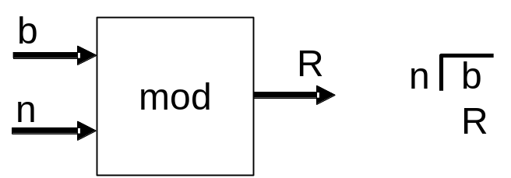
i

- A 16-bit barrel shifter is a combinational logic circuit with 16 data inputs, 16 data outputs, and 4 control inputs. The output word equals the input word, rotated by a number of bit positions specified by the control inputs. Design the barrel shifter using combinational logic. It should be coded and verified in Verilog.

- A bank of N DRAM memories is used by a digital system to manage memory. Only part of the memory management system is explained here. Later on we will construct the whole system. See figure below. The memories in the bank are enumerated from 0 to N-1. The client makes requests to the memory manager. There are the following types of requests: allocate and free. The request signal is used to indicate the kind of request. The combinational circuit to be designed has N input lines, N output lines and a memory request port called request_num which is used to specify the number of memories required. Each input and output line has associated a DRAM denoting its actual state, busy or free with a logical 1 and 0 respectively, that in the sequel we call chunks of memory. The inputs indicate which memories have been assigned and the outputs specify the available ones in accordance with the required number of memories. The update of the memories states will be made by the sequential logic. The combinational circuit always assigns the first free memory chunks and it is assumed that the number of memory requested is always less or equal to N. The design should be coded and verified in Verilog. N=16 should be assumed.

Note: The combinational circuit might be designed using truth tables but it isn’t recommended, instead you can take into account another approach using defined combinational blocks.

